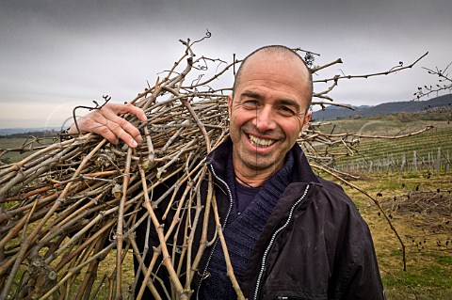

**BRUNELLO DI MONTALCINO 2018**

**PRESALE**

As temperatures drop, leaves flutter to the ground and vineyards drift toward slumber, it is certain that fall is in the air, and winter on its way. Per tradition, this is also the time of year for **the presale of soon-to-be-released Ciacci Piccolomini d’Aragona Brunello di Montalcino 2018 and Brunello di Montalcino Pianrosso 2018!**

The 2018 vintage in Montalcino was widely regarded as a “classic” vintage, characterized by a rainy spring and mild summer temperatures, decidedly less warm (and with fewer heat spikes) than recent years. These cooler temperatures resulted in longer maturation time for the grapes on the vines, presenting wines with acidity, elegance, well-constructed and persistent tannins and a lovely base of fresh fruit. A wide diurnal temperature range in the month leading up to harvest resulted in a vintage that “plays in elegance and finesse,” as described by James Suckling. Indeed, the 2018 Brunello wines present undoubtable complexity, while maintaining an exceptional finesse and territoriality - an ideal combination.

**BRUNELLO DI MONTALCINO 2018**

*“Roasted herbs, walnuts, olives, dried cherries and balsamic on the nose with a touch of leather and sage. It’s full-bodied with firm, finely-knit tannins. Creamy and so well integrated with depth and class.”* **95 points, James Suckling**

**BRUNELLO DI MONTALCINO PIANROSSO 2018**

*“This is so complex with lifting citrus and herb undertones to the blue and red berry fruit. Thyme, sage and lavender, with mocha and clove, too. Full-bodied, full of depth and intensity, with firm yet seamless tannins. Evolves to espresso. Balanced, powerful, and very long.”* **97 points***,* **James Suckling**

The 2018 vintage offers elegant wines distinguished by longevity and a “territorial” expression of Sangiovese, capable of exhibiting the charming complexity for which this grape is so esteemed. And while delightfully approachable even now, with time each bottle will continue to evolve, telling its own unique story.

**Description VINTAGE PACK/SIZE PRICE QTY PRESS**

**BRUNELLO DI MONTALCINO 2018 12x750 _______ ________ 95 JS**

**BRUNELLO DI MONTALCINO 2018 6x375 _______ ________ 95 JS**

**BRUNELLO DI MONTALCINO PIANROSSO 2018 12x750 _______ ________ 97 JS**

**BRUNELLO DI MONTALCINO PIANROSSO 2018 3x1500 _______ ________ 97 JS**

**BRUNELLO DI MONTALCINO PIANROSSO 2018 1X3000 _______ ________ 97 JS**

**BRUNELLO DI MONTALCINO PIANROSSO 2018 1X5000 _______ ________ 97 JS**

ACCOUNT: _____________________ REP: ____________________________ SIGNATURE: _____________________________

indigenous selections

indigenousselections

indigenouswines



WWW.INDIGENOUSSELECTIONS.COM